**Instruction: Use R Studio to complete this practice.**

**Part A:** Comparison of the means of two sets of paired samples.

A school athletics has taken a new instructor, and want to test the effectiveness of the new type of training proposed by comparing the average times of 10 runners in the 100 meters. The time (in seconds) before and after training for each athlete is recorded as follows:

Before training: 12.9, 13.5, 12.8, 15.6, 17.2, 19.2, 12.6, 15.3, 14.4, 11.3

After training: 12.7, 13.6, 12.0, 15.2, 16.8, 20.0, 12.0, 15.9, 16.0, 11.1

1. What type of t-test if we want to compare the means for both datasets (before and after)? Why?

Paired t-test, since these datasets are related, because data was collected from ‘matched’ samples

1. Run a t-test to compare the two means. Assume that the normality assumption is not broken.

$$H_{0}: μ_{D}=0$$

$$H_{1}: μ_{D}≠0$$

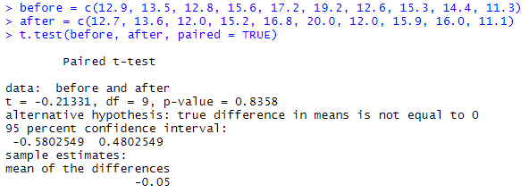

As significance value equals to 0.8358 (p > 0.05), this test is assumed to be non significant. We have to accept $H_{0}$. Conclusion: the new training has not made any significant change in results of athletes.

1. Suppose now that the manager of the team (given the results obtained) fired the coach who has not made any improvement, and takes another, more promising. We report the times of athletes after the second training as follows:

Before training: 12.9, 13.5, 12.8, 15.6, 17.2, 19.2, 12.6, 15.3, 14.4, 11.3

After the second training: 12.0, 12.2, 11.2, 13.0, 15.0, 15.8, 12.2, 13.4, 12.9, 11.0

Run a t-test to check whether the mean of the values before training is higher than the mean of the values after the second training.

Mistake: forgot to write the $H_{0}, H_{1}$- solved

$$H_{0}: μ_{D}=0$$

$$H_{1}: μ_{D}>0$$

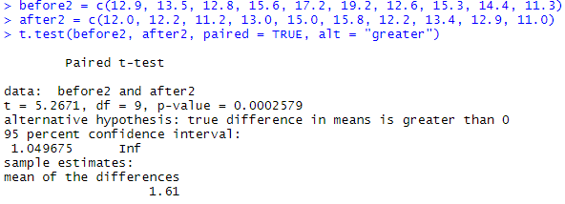

We had written: t.test (before2, after2, paired = TRUE, alt = "greater"), we asked R to check whether the mean of the values contained in the vector before2 is greater than the mean of the values contained in the vector after2. As significance value equals to 0.0002579 (p < 0.05), this test is assumed to be significant. We have to reject $H_{0}$. Conclusion: the new training has made significant change in results of athletes.

**Part B:** Assuming that the dataset in Part A (3) is from two different populations. Run a t-test to compare the means. Assume that the normality assumptions are not broken.

Firstly, we need to check homogeneity of variances.

$$H_{0}: homogeneity of variances can be assumed$$

$$H_{1}: homogeneity of variances cannot be assumed$$

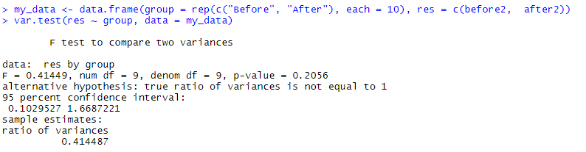

As significance value equals to 0.2056 (p > 0.05), this test is assumed to be non significant. We have to accept $H_{0}$. Conclusion: homogeneity of variances can be assumed. Now, we can perform independent t-test.

Mistake: used F-test rather than Levene’s test – solved

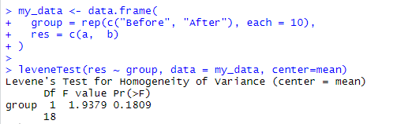

As significance value equals to 0.1809 (p > 0.05), this test is assumed to be non significant. We have to accept $H_{0}$. Conclusion: homogeneity of variances can be assumed. Now, we can perform independent t-test.

$$H_{0}: μ_{1}- μ_{2} =0$$

$$H_{1}: μ_{1}- μ_{2}≠0$$

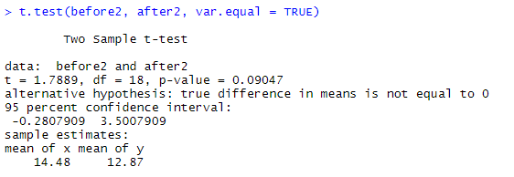

As significance value equals to 0.09047 (p > 0.05), this test is assumed to be non significant. We have to accept $H_{0}$. Conclusion: average result of athletes before training is not significantly different from average result after the second training.